Prayer Zone

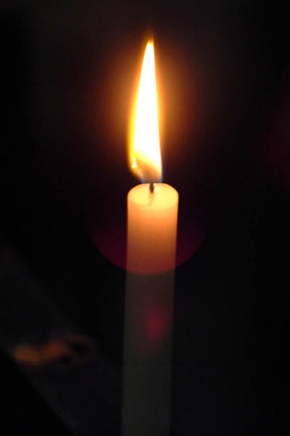
Advent
Prayer
and
Reflection

Monday 2ndDecember
from 4.00p.m. to 7.00 p.m.

An opportunity for personal prayer
and reflection as we begin Advent.
We will be led in prayer on the hour, every hour
and the remainder of the time is for You before God.

