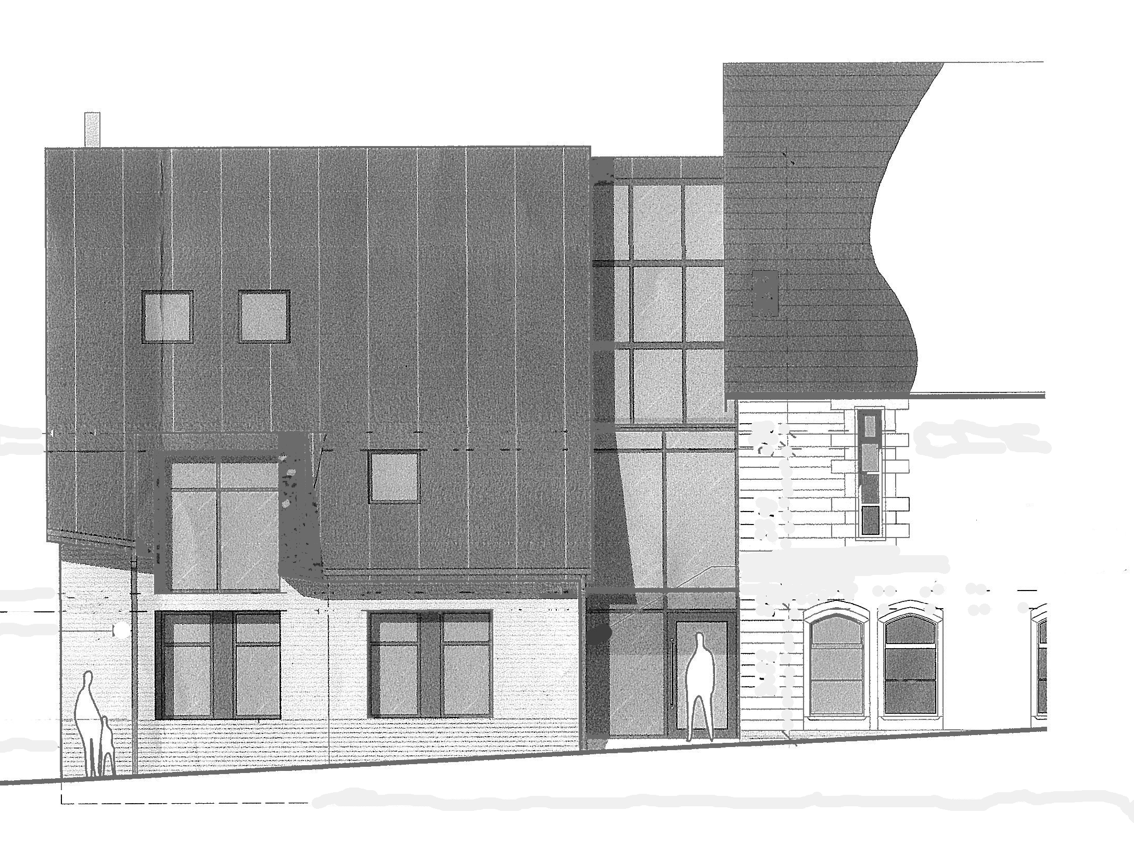

Annexe Update No.5. February 2020
Some of you may have noticed that things are starting to happen around Wellspring! Ground investigations took place in December involving trial pits and a borehole in the parking area. There were no ‘surprises’ and the results will enable the structural engineers to design the foundations and structure of the Annex. You may have also noticed holes in the ceiling of the hall around the existing beams and pillars – again to give the engineers the information they need to design the beams that will replace the cast iron pillars.
From samples provided by the architect, we have chosen the bricks and zinc roof coverings though these will need to be approved by the Council. We have also decided to incorporate small serveries at the back of the hall, where the vestry is now and in the new large meeting room. These will give more flexibility in how both old and new spaces can be used and have enabled us to obtain confirmation from HMRC that the new Annex will not be liable for VAT. We also decided to install a better lift in the annex, giving access from street level down to the new kitchen/café area and up to the new large meeting room, again improving the flexibility in how we use the building. Alongside this, we have decided that the upper floors will be constructed of timber, a more cost-effective and sustainable option than concrete.
We will soon need to decide on the design and construction of the windows and on the fire suppression system. We have two alternatives but both will require an up-grading of the water supply to Wellspring for which we need to work with Seven Trent. We have been advised that this will not be cheap! In the meantime, our Mechanical and Electrical Engineers are designing the heating system and we have had a visit from consultants who will advise us on a new audio-visual system in both the Annex and existing building.
All this on-going work means we have more bills to pay. However, we have now received ‘Final Consent’ from the Methodist Church, meaning that we can start drawing on the £310,000 of funding from various Methodist sources. Unfortunately, the latest cost estimates show that at February 2020 prices, the Annex will cost £765,000, an increase of around £70,000over the £694,000 we calculated in October last year. Our fundraising currently stands at £630,000with two or threegrant applications still outstanding giving a current shortfall of £135,000,so on the information presently available, its very likely we will need to use some of the Bonsall Cottage proceedsintended for manse and cemetery maintenance.
With thanks
David Hughes

