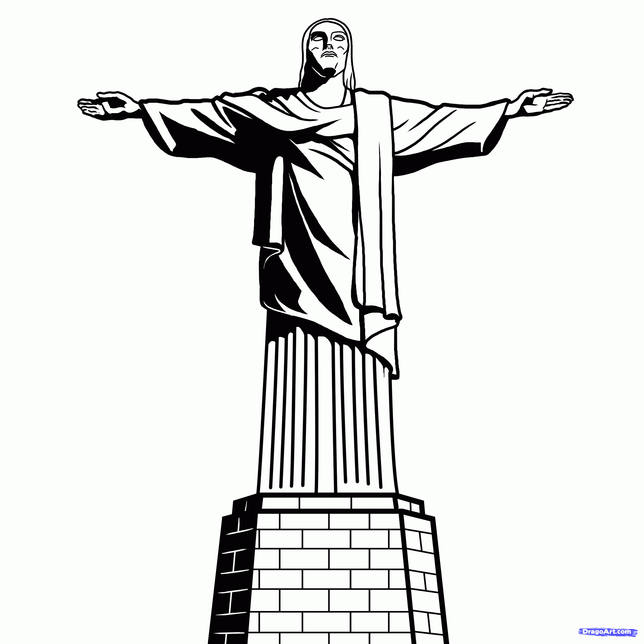

Attraction

I wonder what we find really attractive? The answers may well be as many as the number of people who read this; and they will certainly be as varied. In life, some things just seem to have more pulling power, they draw the crowds, they grab our attention. We might think of a certain person or a particular place as attractive.Someone who is greatly loved, whose presence we enjoy; or somewhere we feel compelled to return again and again. Maybe we delight in telling others of our love for that person and how special that place is.
What if that person is Jesus and that place is Golgotha, the place of his crucifixion and death?

One of the most famous statues in the world is Christ the Redeemerin Rio de Janeiro, Brazil. Larger than life, this art deco figure is 30 m (nearly 100 ft) tall and, standing arms outstretched overlooking the city on top of the Corcovado mountain, it is prominent, and attracts some two million visitors a year, tourists and pilgrims alike.

Every year at Easter we remember the events surrounding the death of Jesus. How he shared a last meal with his disciples using the broken bread and poured out wine as images of his imminent suffering death. Then how he was arrested, imprisoned, beaten, tried and executed by being nailed to a cross on a hill outside the walls of Jerusalem, a place where the city’s rubbish was dumped. Certainly not an attractive location; and, so disfigured by the beating and act of crucifixion, neither was there anything attractive about his battered body. (Isaiah 52:14)

Yet this broken man and this place of execution have become a source of universal attraction. Earlier in his ministry and speaking of his coming death and resurrection, Jesus said ‘but I, when I am lifted up from the earth,will draw all people to myself’ (John 12:32) and that’s exactly what he did, and is doing, as for almost 2000 years people have been drawn to the cross, recognising that in thisman and in this death God IS reaching out to all people with outstretched arms of love.And how attractive is that?

Happy Easter!
Kevin

